Interpreting an IDEOM worksheet

Setting up
- First, double click on the filename to open it in Excel.
- Wait for a while!
- You should now have an IDEOM spreadsheet that looks like this:
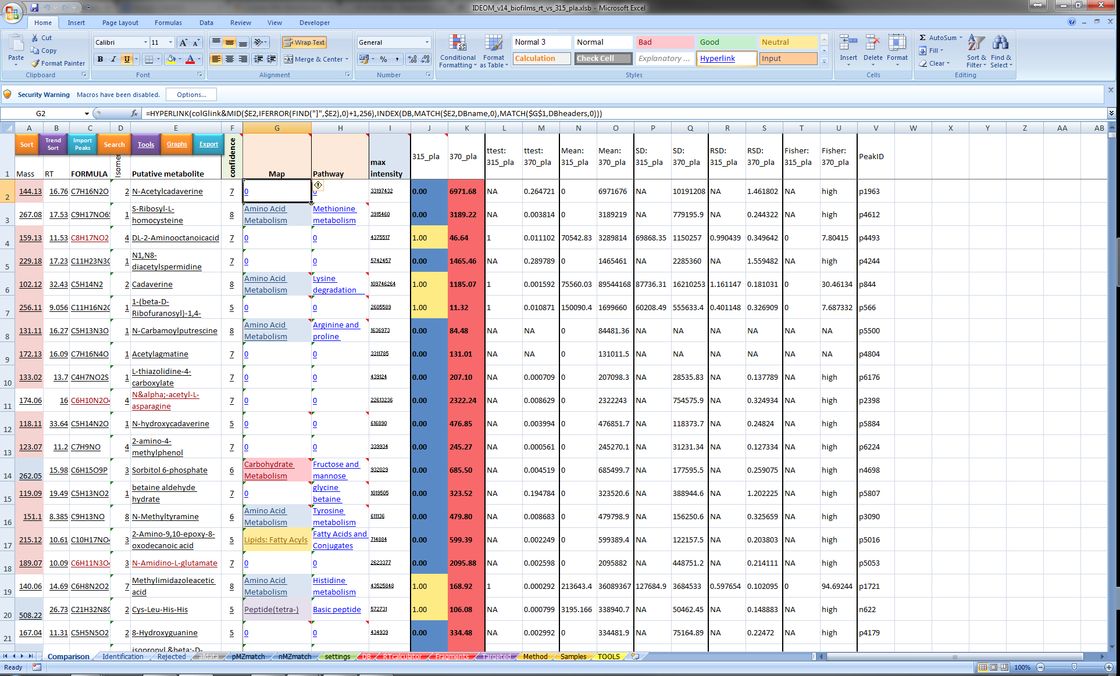
- To start the analysis, we need to enable macros (embedded programs that help with certain functions) in Excel.
- Click on the Options… button next to Security Warning.
- This dialog should appear. Click ‘Enable this content’, then OK.

Structure of an ideom file
There are several worksheets at the bottom of the file:
Some of them are commonly used when performing a routine analysis – these are titled in bold on a yellow background in the text that follows. The rest are housekeeping sheets or sheets for specific purposes beyond the scope of this document and will be described only briefly. From left to right, they are:
- AllBasePeaks is the first sheet. In it are all the unique metabolite peaks that have been detected, whether we’ve been able to identify them or not. This sheet is useful if you are treating an organism with a new drug that isn’t in our database: you might be able to find it here, along with other compounds we wouldn’t expect to find in a typical metabolomics experiment.

- Comparison is the sheet that one spends the largest amount of time in. Simply put, this sheet allows you to compare a group of replicates to one or more other group of replicates. Univariate statistics are applied to the data, and there are links to other databases and tools. A more detailed description of how to work with this sheet follows in the next section.

- Identification is probably the second most important sheet. This sheet is very similar to the comparison page, but works on a per sample basis. No statistics are applied to the data here, but many more details on the individual peaks can be found. Additionally, the raw intensities of the peaks are listed on this sheet.

- Rejected peaks: This sheet contains compounds that are excluded from the analysis for various reasons, encapsulated in the confidence score. The confidence score will be defined in detail in the next section. Some compounds of interest may be found in this sheet, but read the confidence score report carefully before including them in your analysis.

- AllData is very similar to the AllBasePeaks sheet, except that AllData also contains adducts and fragments that have been excluded from the AllBasePeaks sheet.

- pMZMatch and nMZMatch: This is the raw data from the processing pipeline. It contains a list of masses in the first column, retention times (in seconds) in the second column, then each column consists of the intensities of that mass/retention time pair for a particular sample. pMZMatch contains positive ionization mode data, nMZMatch contains negative ionization mode data. Of note in this section are the two bar charts. These contain the median (Median) peak intensities and total (TIC) peak intensities for the entire positive or negative dataset. It’s a very good way of determining whether your samples are consistent and extraction has been performed well.

- Settings: This page contains all of the processing steps to create the other datasheets. If you’ve received an IDEOM file from someone else, you shouldn’t need to alter anything on this page. Creating and processing an IDEOM sheet is beyond the scope of this document. Briefly, the processing steps used to generate the file are on the left, settings for the algorithms used to process the data are under IDEOM Settings, you then have Study Group Information, which contains the locations of your sample types and replicates, then some info on confidence score, (vide infra). Finally there is a normalization section, which should only be used if your samples are very different from each other in concentration (this is done during processing).

- DB: This worksheet contains the metabolite database used to identify and provide context for the compounds that have been detected. Each metabolite has a mass, formula, name, retention time (of a standard (sRT) or predicted (cRT), see RTCalculator, the next worksheet), then a series of columns providing information about the metabolic pathways that the compound belongs to, then various identifiers for the metabolite in different databases, and finally a large number of physicochemical properties.

- RTCalculator: This worksheet is a little complex, and is used only when setting up the IDEOM sheet. The background to this sheet is that while we have 40,000 compounds in our metabolite database, many of these are impossible or very expensive to obtain as standards. We therefore use the panel of standards that we do have (which are listed down the side of the sheet) to function as seeds to predict the retention times of the other compounds. This information is then updated into the DB worksheet and used to identify the metabolites that we detect. One major caveat is that the prediction is quite poor, so identifications made with the RTCalculator must be evaluated carefully.

- Fragments, Method and Samples are housekeeping sheets. Fragments are used to assign identity to peaks that correspond to known metabolites that have lost parts of their structure during the spectrometry process. Method and Samples are for the records of the user.

- Targeted and TOOLS are collections of functions that are not commonly used.

Confidence Scores in IDEOM
Confidence scores range from 0-10. These scores are completely arbitrary, and based on the software developer’s own interpretation of the data. They do not conform to the Metabolomics Standards Initiative classification system for publication purposes.
Some compounds are listed in bold type on a yellow background. These compounds (with scores of 8, 9 or (usually) 10) are matched within 3ppm of the mass and 5% of the retention time of an authentic standard that we run prior to every batch of samples. These are classified as identifications according to the MSI – this does not mean that they are definitely correct! Some compounds, e.g. leucine and isoleucine, have very similar retention times and identical masses. It’s very important to discuss the quality and confidence of the IDs prior to publication. However, for the majority of peaks, matching mass and retention time to a standard is good enough to be happy with an identification.
Those compounds in bold on a yellow background with scores of 8 are compounds that match a standard, but there is another compound at the same retention time that it could well be a fragment of, so be careful of these IDs.
Scores of 8 or lower, without bold type and yellow backgrounds are identifications based on predicted retention time. At the left of the ‘putative metabolite’ column is a column marked ‘Isomers’. This shows the number of different compounds that have identical chemical formulas, but different structures. These are indistinguishable by mass spectrometry alone, and retention time or other methods should be used to distinguish one from another.
To see the different isomers for a given compound, click on the compound’s cell. A down arrow should appear on the right hand side of the cell.
Click on the down arrow, to get a list of different compounds. In this case there are only 2.
It is important to bear in mind that both identifications are equally likely.

Interpreting data in The comparison Worksheet
As previously described, the comparison worksheet is the most important one, and also the sheet that the user will spend the majority of their time in.
From left to right, the columns in the sheet contain:
- Mass: the accurate monoisotopic mass of the compound. Double clicking on the mass will provide a mass spectrum of the peak and peaks eluting at the same time with the same chromatographic peak shape (i.e. related peaks). Base peaks are shown in green. Hovering the mouse over the peak will pop up an image of the chromatographic peak for that compound on some datasets.
- RT: Chromatographic retention time of the compound. Double clicking on this will produce a scatter plot of the retention and intensity of the sample sets. If you have R installed, it can also run a script that provides a chromatogram for the peak, identical to the mass hover-over, if available.
- FORMULA: Chemical formula of the compound. With a window of 3 ppm (parts per million), it is usually possible to assign a single chemical formula to a compound. There are rare cases where this is not the case, however. Double clicking on the formula provides a search of all possible adducts, fragments and isomers for this compound.
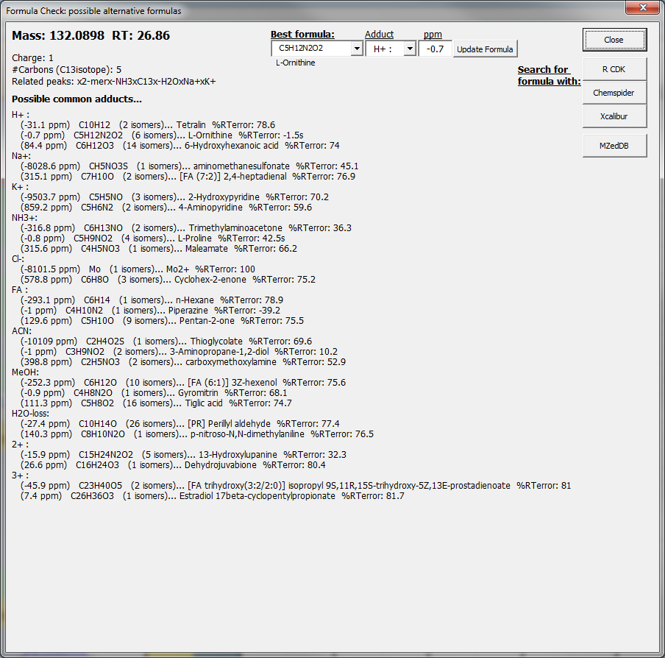
- Isomers: number of isomers (vide ultra). Double clicking on a cell gives the list of potential isomers for this compound, and some additional information about pathways they belong to.
- Putative metabolite: The most likely assignment for a peak, based on accurate mass, and, in the case of bold compounds on a yellow background, the retention time of a standard, or for other compounds the predicted retention time. Double clicking on the putative metabolite will provide a graph showing the mean intensity of the compound across all sample sets, with error bars.

- Confidence: the confidence score for an identification, in arbitrary units. Double clicking on the confidence score will provide a popup window describing why that isomer is given that particular score.
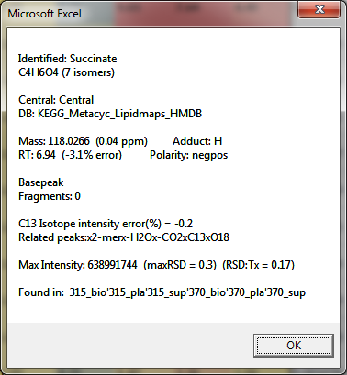
In this case, the compound is mass matched at a level of 0.04 ppm, and 3.1% retention time error. There are no fragments to consider, but there is a doubly charged version, a water loss, and several isotopes have been detected. Isotope intensity is also matched well with only a 0.2% error, providing improved confidence in the formula assignment.
- Map: the overall class of compound. Click on the Map heading to pop up a list allowing you to change map to database id, pathway, kegg pathway, etc.
Double clicking on the map provides a link to the chemspider page on that particular compound.
- Pathway: the specific metabolic pathway for the compound. Like the Map heading, the header can be clicked on to allow selection of a variety of different fields. Double clicking on the pathway takes you to the kegg pathway described.

- Max Intensity: This is the maximum intensity (in counts – an arbitrary unit) that the specific compound has been detected at. Double clicking on this value provides a graph of individual intensity values for each sample, rather than averaged values.
- The next columns are the sample sets you have selected, and their relative fold changes. The intensities of all compounds in the ‘control’ set are set to 1.0 and the values of all other sample sets are compared to this, e.g. CMP is downregulated about 3-fold (1:0.37) in 370 cells as compared to 315 cells.
Undetected levels in the controls are designated as 0.00. Values in other sample sets cannot be statistically compared to undetected levels and should be disregarded from statistical analysis.
- Following these columns are ttest scores, means, standard deviations, relative standard deviations and Fisher scores for each sample set.
The comparison sheet also has a number of buttons at the top which launch additional features. Many of these require R and the appropriate packages to be installed, so may not be available.
- Sort is described under ‘focusing on standards’, below.
- Trend sort looks for correlations in expression between different metabolites. To see what compounds have similar patterns of expression compared to a particular metabolite, click the ‘trend sort’ button (red below).
A dialog box pops up, asking you to select the ‘name’ of the starting metabolite (green, above). Select a metabolite (e.g. D-Glucose, as shown), and click ok.
The sheet is now sorted by expression similarity to the selected metabolite.
- Import peaks allows incorporation of popup windows showing the chromatographic peaks into the ‘mass’ column. This is performed during dataset preparation.
- Search allows a compound to be searched throughout the data. 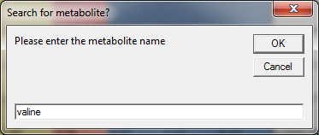
An additional sheet may pop up allowing you to select a particular metabolite out of a selection:
Clicking OK triggers a search for the metabolite, which takes you to the cell containing it.
- Tools contains a variety of different features, these are beyond the scope of this document.

- Graphs contains a variety of plots that can be produced. The most interesting are volcano plots: select the minimum fold change for the plot (the default of 2 is usually fine), and click ok. The volcano plot graphs fold change against t-test significance. Higher compounds are more significant, compounds further away from 1.00 on the X-axis have greater or lesser fold changes.
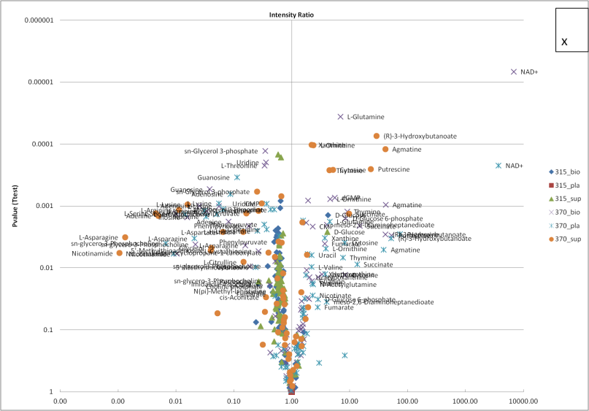
- Export contains a variety of different features. The most useful ones to the user are export to R and Pathos. While export to metaboanalyst, iPath and metexplore are useful for specific purposes, they are beyond the scope of this document. Export to ‘R’ only works if R and the appropriate packages are installed on the system. Triggering this on a functioning workstation results in generation of a sample dendrogram, a metabolite dendrogram, a clustered heatmap, a PCA scores plot and a PCA loadings plot.

Using Pathos for Network Analysis
For pathway and network analysis, Pathos is a useful feature. To activate Pathos, click the ‘Export’ button on the comparison sheet, and click on ‘Pathos’ in the dialog box that appears.
Clicking the button produces a dialog box:
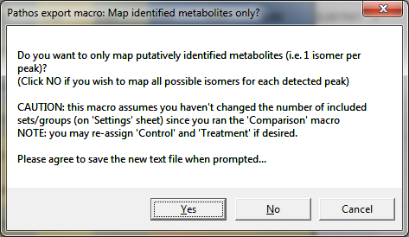
If you wish to allow all possible identifications, click ‘no’, if you wish only to use those IDs that have been putatively assigned by matching to retention time standards and calculated retention time, click ‘yes’. Some processing occurs, and a text file is created in the same directory as the IDEOM worksheet, called ‘pathos_KEGGlist.txt’. If this already exists, it will prompt you to save over it.
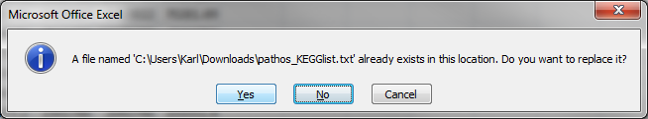
Click ‘yes’, and it will prompt you to save it again. Click ‘yes’.
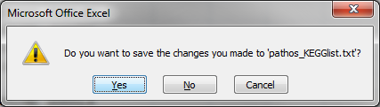
The following message box appears:
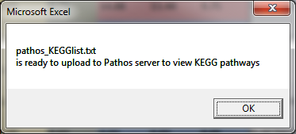
Click ‘Ok’, and a link to a website is triggered.
Click the ‘choose file’ button and find the ‘pathos_KEGGlist.txt’ file that you just created, then click the ‘upload’ button. This window should appear:
Select the organism of interest, then your base (control) condition and your experimental (treatment) condition. You can also change the colour coding for fold changes here if desired. Then click ‘run’.
Pathos organizes detected metabolites into biochemical pathways, ranked by the pathway with the most detected metabolites. Clicking the green down arrow (circled in red below) next to a pathway provides a list of each compound in the pathway.
You should now see a list of detected compounds with the letter ‘G’ on a coloured background on the left and their chemical formulas on the right. The colour coding is according to the key (which can be shown and hidden by clicking the blue circled link). Clicking on a ‘G’ pops up a graph with error bars for the intensity of that compound in each sample set.
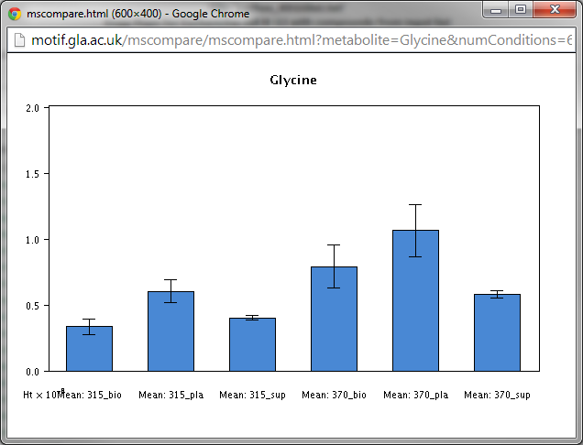
Finally, by clicking the link in the ‘Generate map of XX highlighting potential metabolites’, the detected metabolites can be mapped to the KEGG pathways and colour coded according to the base and experimental conditions and fold changes selected initially.

Focusing on standards
Generally, the user will want to focus on identifications matched to authentic standards. To do this, click the ‘sort’ button in the top left hand corner of the sheet.
The following dialog should appear. Click ‘No’.
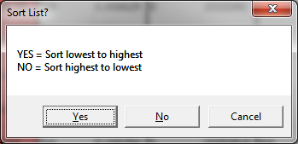
This dialog should appear:
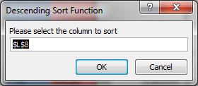
Click ‘F’ to highlight the confidence column.
Then click OK in the dialog box. After some processing, the sheet should look like this:

Restricting analysis to significant changes
It’s very useful to remove insignificant changes and non-statistically comparable values from the analysis, so that significant changes may be focused on.
Click ‘sort and filter’ on the Excel toolbar, then click ‘Filter’.
Small down arrows should appear at the top of each column.
Click the down arrow at the top of the ‘ttest’ column of your ‘treatment’ column and select ‘Number Filters’.
Now click ‘Less than or Equal To’. The dialog box shown below should appear. To set a 95% significance threshold, put 0.05 in the text field as shown below, and click ok:
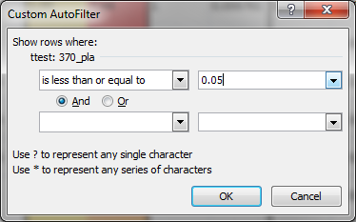
This will now restrict the identifications to those with t-test scores of lower than 0.05. Please bear in mind that these values are not corrected for multiple testing. Bonferroni or Benjemini-Hochberg False Data Rate correction should be applied to confirm differences.
Additionally, the data should also be filtered to remove samples where the ‘control’ value is 0, as these cannot be compared statistically. To do this, ensure that filtering is still on, and click on the small down arrow next to your control sample set’s column.
Deselect the 0.00 values and click ok. The ‘control’ column should now only have 1.00 values in it.

Ranking by fold change
To rank the entire analysis by fold change and view all of the compounds, both matched to standards and putatively assigned, simply use the sort button (red, below) to sort by the fold change of the sample set you are interested in (in this case, 370_pla).
Then, to exclude metabolites whose statistics are poor, filter by significant changes (as shown above).
Now evaluate the data as described below.

Interpretation of filtered data
In this example, we are comparing Streptococcus, grown as a biofilm, the bacteria remaining in the medium (planktonic cells) and the medium itself for two different strains of Streptococcus pyogenes – strain 315 and 370.
It is not meaningful, in this experiment, to compare different sample types (e.g. biofilm to medium), but it’s very feasible to compare strain 315 planktonic cells to strain 370 planktonic cells and so on.
For the moment, we’ll focus on the comparison between planktonic cells from the two different strains (315_pla vs 370_pla).
Let’s look at the sorted data that we created:
The top hit is Cadaverine. This compound is hugely upregulated – over 1000-fold. Along with this, many other compounds involved in amino acid metabolism (ringed in red) are upregulated. Clearly there’s something going on in amino acid metabolism between strain 370 and strain 315.
Let’s look at the bottom of the datasheet, at the downregulated compounds.
Many compounds also in amino acid metabolism are downregulated, some up to 50-fold, along with a lot of compounds identified as peptides. Perhaps there is something very different involving protein synthesis or amino acid metabolism between the two strains?
Let’s look at the pathways in more detail by using Pathos: There’s no organism for Strep in the database, but let’s choose Staph aureus, as it’s another gram positive coccus.
Arginine and proline metabolism is the top hit, with 17 identified metabolites. The colour coding shows that quite a few of the metabolites, especially glutamate, glutamine and similar compounds aren’t changing at all (yellow) but some are hugely up (blue), and some are hugely down (red).
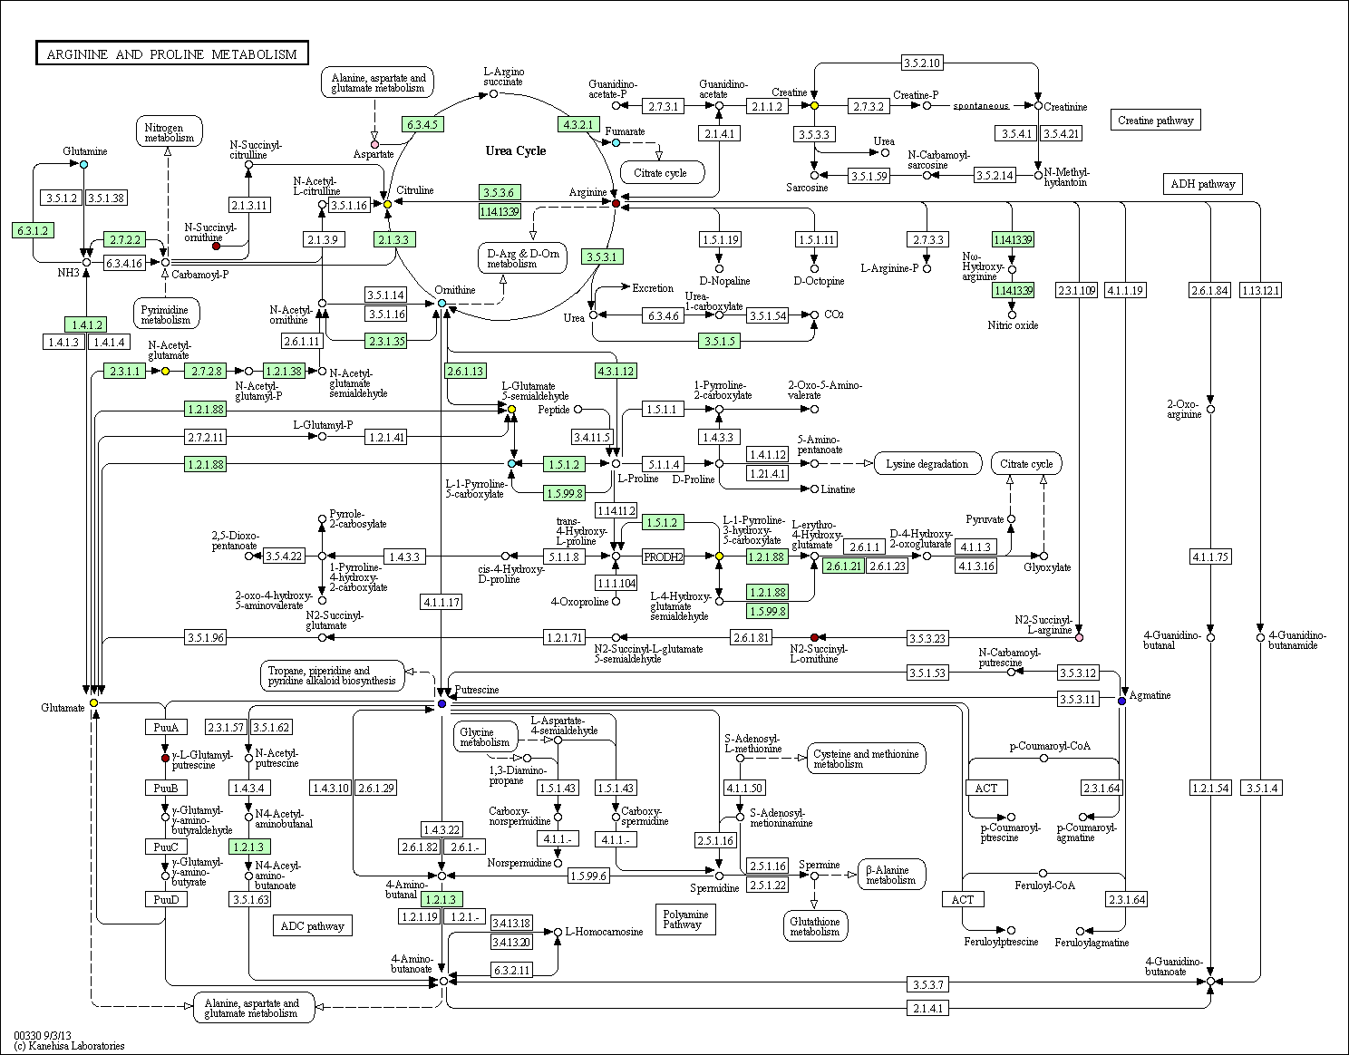
Lots of metabolites are either going up or going down in this particular map. One branch from the urea cycle, for example, from arginine, through n2-succinyl L-arginine, to N-2-succinyl L-ornithine, is hugely down in strain 370, but the production of ornithine, putrescine and agmatine are hugely up. Glutamate, on the other hand, is stable, and both pathways eventually end up there.
At this point, further interpretation should be performed with reference to the literature and the expertise of the researcher.

Changing the experiment settings to compare different sets
To change the comparisons used in the Comparison worksheet, we need to go to the ‘Study Group Information’ panel in the ‘Settings’ worksheet. The parameters you have to change are under ‘Set-Type’ in Sample groupings
You must always have one Control and one Treatment for the comparison, but it’s possible to set multiple sets to ‘Sample’ and allow them into the comparison sheet, e.g.:
To activate this, or change the control sample and treatment sample to different sets (e.g. to compare 315_sup to 370_sup), change the control and treatment assignments by clicking on the box next to the sample set and selecting the appropriate assignment. Following that, click ‘8. Compare all sets’ and wait for about 10 minutes for the processing to occur.

